Curriculum Vitae

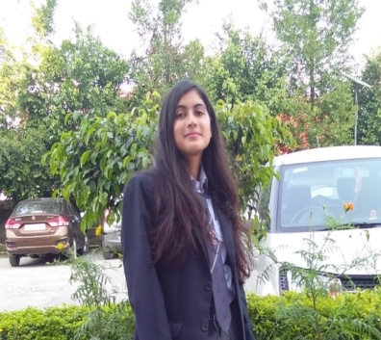
Name: Reshma Mundiyafi
Address:Jhiwarhedi, Post office- karbari grant,simla by pass road,Tahsil- Vikasnagar,Distt.-Dehradun,
PIN-248007, Uttarakhand.
Contact No. : 7247830339;
E-mail ID:reshmamundiyafi8@gmail.com

Objective-A creative resourceful science teacher with a master’s degree in
education.My dedication in teaching will be very beneficial in providing quality
Education to the students.

Educational Qualification:
Sr. No. | COURSE | Subjects | YEAR | UNIVERSITY/COLLEGE | MARKS (Aggregate percentage)
1 | M.Sc | Biotechnology | 2018-2020 | Graphic Era Deemed to be University, Dehradun, Uttarakhand. | 78.2%
2 | B.Sc | Biotechnology | 2018 | Shri Guru Ram Rai (p.g) college(Hemvati Nandan Garhwal University, Srinagar(Garhwal), Uttarakhand. | 67.7%
3 | 10th | Mathematics, English, Social science, Hindi,Science. | 2013 | Government inter college (Guliyari )Pauri Garhwal, (UttarakhandBoard). | 71.5%
4 | 12th | Physics, Chemistry, Biology, Hindi, English | 2015 | Government Inter college (Guliyari)PauriGarhwal (Uttarakhand Board). | 74.4%

Work experience: currently working as a science instructor in Sixth Sense an e-learning production company from 3 march 2021.

Technical Skills:

- Basic of MS Word, MS Excel, MS PowerPoint.
- Microbial culture and growth.
- Electrophoresis and PCR.
- Plant tissue culture and animal cell culture.
Dissertation
Undergone project for M.Sc biotechnology final semester at Delhi Technological University at Delhi for duration of 6 months (January-june 2020) involved in the research of “Synthesis of Copper Nanoparticles by Green Synthesis”.
Industrial training
Ex. Hands on industrial training on " Real Time Pcr" (Oct 22-23, 2018), organized by Department of Biotechnology and Department of Life Sciences, Graphic Era deemed to be university Dehradun in association with TaqGene Training and Research Institute (TGTRI), Dehradun.

Conference/Seminar/Workshop:
Example
AttendedInternational Conference on Medicinal, Aromatic and Neutraceutical Plants from Mountainous: 9th Annual conference of American Council for Medicinally Active Plants (ACMAP), organized by Graphic Era Deemed to be University and ACMAP at Graphic Era (February 14-16, 2019).
One day workshop on Recyclingof waste paper organized by department of physics, graphic era hill university, dehradun Department of biotechnology, graphic era deemed to be university held on(September 4 2018).
Three days workshop on Computer Aided Drug Designing, held from( November 15-17, 2018) jointly organized by Department of Biotechnology and life sciences,Graphic Era Deemed to be university, Dehradun in association with TechMutation consultancy and young Mind Research and development (YMRD),Dehradun.

Strengths:
- Leadership quality and Self disciplined
- Passionate to works
- Open to learn.
Hobbies:
- Reading
- Travelling.
- Watching inspirational movies.

Personal Details:
- Date of Birth: 1January 1996
- Parents Name: Mr. Ram Prasad Mundiyafi &Mrs.Yashoda Devi.
- Languages Known: English and Hindi
- Permanent Address: Jhiwarhedi, Post office - karbari grant,Tahsil-Vikasnagar,Dehradun, Pin code -248007, Uttarakhand.

Place: Dehradun
Reshma Mundiyafi

