Divya Aggarwal(Mittal)
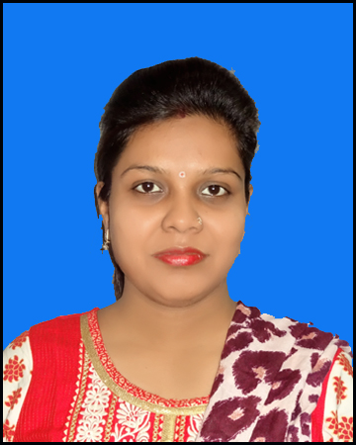

Address:
Divya Aggarwal
D/O Mr. Vinod Kumar Aggarwal
Near CBI Main Market- Selaqui
D.dun(UK)
E mail: divya.aggarwal53@gmail.com
Mobile: +91 8449991716

OBJECTIVE

To reach a position in my life where I would be able to significantly influence the work environment around me by inculcating conceptual, technical and human skills.

ACADEMIC BACKGROUND
Year | Qualification – Degree / Diploma / Certificate | Board | College/ Institute/ University | % of Marks
2019 | NET(Education) | UGC-NTA | - | -
2014-2015 | M.Ed | H.N.B. Garhwal University Srinagar (UK) | Pestle Weed College Dehradun | 73.83%
2011-2012 | B.Ed | Uttarakhand Technical University | Beehive (P.G) College D.dun | 84.5%
2009-2011 | M.Sc (Physics) Specialization in electronics | H.N.B. Garhwal University Srinagar (UK) | D.A.V (PG) College D.dun | 65.69%
2006-2009 | B.Sc (P.C.M) | H.N.B. Garhwal University Srinagar (UK) | D.A.V (PG) College D.dun | 60.77%
2006 | SSC | UA Board | Govt. Inter College Selaqui, D.Dun | 65%
2004 | HSC | UA Board | Govt. Inter College Selaqui, D.Dun | 63.5%

ADDITIONAL QUALIFICATION

- 5 year teaching experience as Assistant Professor (Education) at Pestle Weed College of Information Technology,Dehradun.
- M.A(Psychology) from UOU.
- More then 8 years of experience of Secondary Education.

COMPUTER SKILLS

- 1 year Diploma in Computer from Websoft Computer Education Dehradun.
- Internet Surfing And Mailing.

PERSONAL DETAILS

Father’s Name : Shri. Vinod Kumar Aggarwal
Mother’s Name : Smt. Beena Aggarwal
Date of Birth : 20-03-1988
Religion : Hindu
Nationality : Indian
Gender : Female
Marital Status : Married
Languages Known : Hindi and English
Hobbies : Net-Surfing, Listening music, Playing
Bad-Minton, and Reading books.
Major Strength : Positive thinking, Ability to work in a team, Motivating
People easily, Handling Difficult & Sensitive situation
Tactfully & responsibility.

DECLARATION

- I do hereby declare that entire information provided me are true according to the best of my knowledge and belief.
- If given a chance I will do my best to satisfy the expectation of concerned Institute.

DATE: 18/06/22 SIGNATURE
DEHRADUN (DIVYA AGGARWAL)

