Name : vivek kumar  - Accurate Institute Of Management And Technology, Greater Noida  - Cell Phone Number: 9999065417  - 9354433701  - E Mail : vivekdbg.kumar@gmail.com  Current Address: Uttam nagar, delhi  Personal Information  - Father’s Name:  Uma shankar singh  - Date of Birth: 20th may 1993.  - Sex: Male  - Nationality : Indian  Marital Status: Single  Languages Known: English, Hindi  - Hobbies –  Playing cricket, listening music, Watching movies, Travelling  - Strength-  Self Motivated, Adaptability, Sincere. | CURRICULUM VITAE  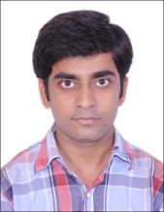  Career Objective:  To pursue a highly rewarding career, seeking for a job in challenging and healthy work environment where I can utilize my skills and knowledge efficiently for organizational growth.  Academic Background:  Year Qualification Institution Subjects Marks/ % CGPA / %  2011-15 Graduation Accurate Institute of Management and Technology B-Tech 68.7 69  2010 12th C.M Science college,darbhanga ^{Science} 62.8 64  2008 10th M.L Academy, laheriasarai. 75.4 76  EXPERIENCE  .part time teaching in kd education gr.noida(2013-15)  .full time teaching in Bharti study circle, vikas Puri(2017-22)  .part time teaching in global key technology, nirman vihar(2019)  Programming Skills:  - CORE Java language  - C programming  - c++  Declaration  I hereby declare that all the information is furnished above is true and efficient to my knowledge.  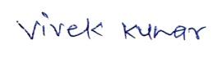  signature

