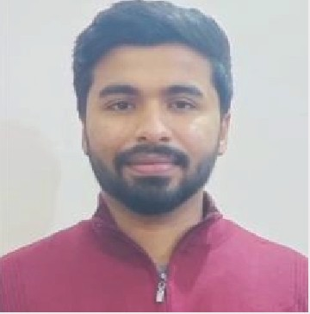

OBJECTIVE
Aim to create individual worth that will add tremendous value to my corporate through professional skills and constantly keep moving up the value chain as dedicated team player who can bring to your organisation excellent skills like analytical, planning, time management.

+91 8527919064
Ak9560536@gmail.com
Dehradun Uttarakhand

LANGUAGES
- English
- Hindi

ABHISHEK KUMAR

EDUCATION
BSc. Mathematics (2019-2022) - 8.20 CGPA
Graphic Era Hill University Dehradun 248002
12(2017) - 72.30%
Delhi Public School, Vidyut Nagar NTPC Dadri Gautam Nagar
l0(2015) - 9.2 CGPA
Delhi Public School, Vidyut Nagar NTPC Dadri Gautambudh Nagar

WORK
Founder & CEO Greenholic Dreamers India Pvt Ltd
Founded startup which focuses on the waste management that significantly meet the demand of pet food in India and also participate in energy generation.
Startup has been recognised by Startup Uttarakhand.
Incubating under TBI- Geu
Formulated a company’s vision, goals, objectives.

ACHIEVEMENTS

JEE Mains and Advance UPTU/AKTU Entrance exam
Represented School on Nationals in Football Tournament
Got 2 price in Energy Generation Project through Hydro powerplant Got 1 price in math's Olympiad

PROFESSIONAL SKILLS
Business Development, Financial Skills, Management Skills, MS WORD, MS EXCEL, HTML

PERSONAL SKILLS
Problem solver, Keen to learn new things, Leadership, Time Management, Teamwork

HOBBIES
Chess, Football, Travelling, Reading

