R E S U M E  Ms. JYOTI CHOUDHARY  Address: House No. 1053, Ground Floor,  Block 22, Lodhi Colony,  New Delhi - 110003  Mobile No.: 9899761354  E-mail: jyoti.choudhary1982@gmail.com | 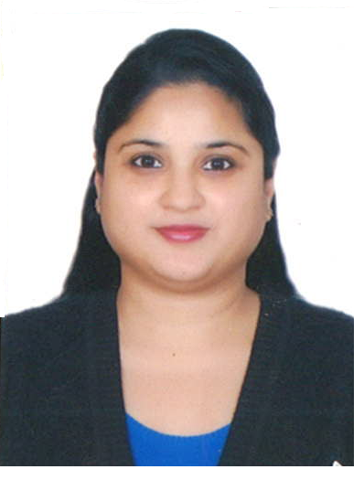

CAREER OBJECTIVE

To get associated with my school that will give me an opportunity to enhance my career in academics.

Professional Qualification:

DEGREE | UNIVERSITY/BOARD | YEAR OF PASSING | % age
B.Ed.  (Subject: English & Life Science) | M.D.U Rohtak | 2014 | 80% in Science, 72% in English
CTET QUALIFIED  Paper I  Paper II | C.B.S.E.  C.B.S.E. | 2015  2015 | 60%  59%
M. Pharm | DELHI UNIVERSITY (D.U.) | 2006 | 71%
B. Pharm | DELHI UNIVERSITY (D.U.) | 2004 | 72%

Educational Qualification:

DEGREE | UNIVERSITY/BOARD | YEAR OF PASSING | % age
XIIth | Father Agnel School, Gautam Nagar, New Delhi (A.I.S.S.C.E.) | 2000 | 84% aggregate  (90% in PCB)
Xth | Father Agnel School, Gautam Nagar, New Delhi (A.I.S.S.C.E.) | 1998 | 81%

Experience:

- Currently working as a Primary Teacher in Raghubir Singh Junior Modern School (RSJMS), Humayun Road, Pandara Flats, New Delhi - 110003
- Possess 5 years of experience as a Primary Teacher in St. Mary’s School, Dwarka.
- I completed M. Pharm & B. Pharm from Delhi Institute of Pharmaceutical Sciences & Research (DIPSAR, D.U).
- I worked as a Research Scientist in Sun Pharma Industries Limited (formerly known as Ranbaxy Laboratories Limited, Gurgaon) for 10 years.

Roles and Responsibilities:
- Fostered student curiosity and interest in learning through hands-on activities.
- Created and adapted lesson plans according to the student’s academic needs.
- Met with parents, administrators to address and resolve student’s behavioural issues and also prepared progress reports for students.
- Worked as a mid-day meal coordinator to promote better food and nutrition habits.

Achievements:

- Microsoft Certified Educator (MCE) from Microsoft in 2020.

- Awarded with the best class trophy in the year 2018-19.

- Awarded as an “Outstanding Scholar” in class Xth in Father Agnel School.

- Honoured with a certificate & a cash prize of Rs. 500 for achieving 95% above marks in both Science & Sanskrit in FICCI auditorium in class Xth CBSE Board examination.

Co-curricular activities:

- Participating in clubs, organizations, workshops, seminars and conferences.

- Attended various workshops from Britannica, Cordova Publications, Alpha Mathematics, Microsoft & other IT related seminars.

- I enjoy playing Badminton, singing & listening music.

Key Skills:
- Problem solving / ability to learn new things

- Accuracy & attention to detail

- Classroom management

- Positive attitude

- MS Word, Excel & Power-point

Areas of Interest:
- Academics (Pre-primary/ Primary)

My Strengths:

- Hard Working

- Focused & dedicated

- Strong Communication & inter-personal skills

- Punctual

Personal details:
- Date of Birth : 17th July 1982

- Sex : Female

- Marital status : Married

- Nationality : Indian

PLACE: NEW DELHI
DATE: 30-JAN-2023 JYOTI CHOUDHARY

